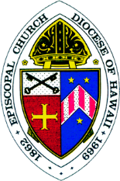
THE EPISCOPAL DIOCESE OF HAWAI‘I
CHURCH MEDIA RELEASE FORM

I certify that I am 18 years of age or older, or am the parent or legal guardian of a minor child, and hereby grant the designated entity permission to use my likeness in a photograph or video in any and all publications of the entities, including website and social media entries, without payment or any other consideration. I hereby authorize designated entities below to edit, alter, copy, exhibit, publish or distribute such photo or video for purposes of publicizing programs, including the Episcopal Diocese of Hawai‘i’s online publication, The Hawaiian Church Chronicle, websites, and social media pages.
I am signing this form: (Check one)
for myself as an adult.
as the parent or legal guardian of a minor.

Print Name: __________________________________________________________________

Church or Organization in the Diocese that this form applies to:

____________________________________________________________________________

Signature: ____________________________________________ Date: __________________

